GHG Emissions Predictive Analysis
Project Report
Prepared by: Rohan S
AICTE ID: STU6888df0b1f6441753800459
College name : University of BDT College of Engineering

Problem Statement
Global greenhouse gas (GHG) emissions have been studied extensively to find ways to reduce their impact by 2030. This project uses historical GHG emissions data to predict future emissions based only on the records provided by individual countries.
The dataset comes from Climate Watch Historical GHG Emissions and contains sector-level emissions data for 194 countries and the European Union from 1990 to 2018. It includes the six major greenhouse gases from different sources and sectors. Non-CO₂ emissions are converted into CO₂ equivalents using the 100-year global warming potential values from the IPCC Fourth Assessment Report.
The dataset was collected from several sources, including FAOSTAT for agriculture and land-use emissions and the OECD/IEA for CO₂ emissions from fuel combustion. The data also accounts for changes in the reporting of European Union emissions after the United Kingdom's departure.
The cleaned dataset will be used to train a machine learning model in Google Colab using Python. The model will learn from historical emissions and predict future GHG emissions for different countries.
The main goal of this project is to develop an interactive tool that can predict future GHG emissions for any country based on historical data. This tool can help users understand possible emission trends and support the evaluation of potential climate scenarios.

Project Objective
The objective of this project is to:
- Clean and structure raw national GHG emissions data into an analysis-ready format.
- Explore historical emissions trends across countries through static and interactive visualizations.
- Analyze the trend, seasonality, and autocorrelation structure of country-level emissions time series.
- Engineer predictive features (lag and rolling-average values) suitable for supervised learning.
- Train and evaluate a regression model that predicts a country's emissions for a given year.
- Provide an interactive forecasting tool to project emissions beyond the observed data (2019 onward).

Dataset Description
Source | United Nations, published via Kaggle
Dataset name | International Greenhouse Gas Emissions
Link | https://www.kaggle.com/datasets/unitednations/international-greenhouse-gas-emissions
Coverage | 1990 – 2018, annual, by country/region
Format | Wide format: one row per country, one column per year, plus a unit column
Unit | Million metric tons of CO₂ equivalent (MtCO₂e)

Before analysis, the raw wide-format table is reshaped into a tidy long format (one row per country-year pair), which is required for time-series analysis and for building lag/rolling features per country.

Methodology

Data Cleaning
- Country/region names are stripped of whitespace and standardized to title case to prevent duplicate entries caused by inconsistent capitalization.
- All year columns are coerced to numeric type, converting any invalid or placeholder values to missing (NaN).
- Total emissions per country are recomputed directly from the yearly columns to guarantee internal consistency.
- Namibia
  - Total 1990 Emissions: ~10.5 MtCO₂e
Source: UNFCCC National Reports (Namibia’s 2nd National Communication, 2011).
- Palau
  - Total 1990 Emissions: ~0.22 MtCO₂e
Source: Pacific Environment Portal (Palau’s GHG Inventory, 2016).
- Micronesia (Federated States of)
  - Total 1990 Emissions: ~0.31 MtCO₂e
Source: World Bank Climate Data.
- Marshall Islands
  - Total 1990 Emissions: ~0.25 MtCO₂e
Source: US EPA Global Emissions Data.

Exploratory Data Analysis
- Bar charts (static and interactive Plotly) rank countries by total emissions.
- An interactive dropdown widget (ipywidgets) lets the user plot any single country's 1990–2018 trend on demand.

Time-Series Decomposition
For a selected country, the emissions series is decomposed into trend and seasonal components (statsmodels' additive seasonal_decompose, 5-year period), along with rolling mean/standard deviation, and autocorrelation (ACF) / partial autocorrelation (PACF) plots to inspect temporal dependency structure.

Feature Engineering
Two predictive features are derived per country, in chronological order:
- lag_1 — the prior year's emissions value.
- rolling_mean_3 — the trailing 3-year rolling average of emissions.
The calendar year itself is included as a third feature.

Model Training
A Random Forest Regressor (200 trees) is trained to predict a country's emissions from (year, lag_1, rolling_mean_3). The data is split in a time-respecting way: for each country, the earliest 80% of years form the training set and the most recent 20% form the test set. This prevents information from future years leaking into training, which a random row-wise split would not guarantee.

Evaluation
Model performance is measured with:
- RMSE (Root Mean Squared Error) — average prediction error in the same units as emissions.
- MAE (Mean Absolute Error).
- R² (coefficient of determination) — share of variance explained by the model.
Performance is reported both globally (across all countries in the test set) and for a configurable list of individual target countries.

Forecasting
A recursive forecasting function, predict_emissions(), extends the model beyond the last observed year (2018). To forecast year N, it predicts year (last_year + 1) using the most recent known values, then feeds that prediction back in as the new lag_1 / rolling_mean_3 inputs to forecast the following year, repeating until it reaches N. An interactive widget lets the user pick a country and target year and view the resulting forecast chart live.
Limitations & Considerations

- Short-Term Focus: Best for 1–5-year forecasts (longer-term requires socioeconomic factors)
- Country-Specific: Trains separate implicit models for each country
- Data Quality: Depends on accurate historical reporting

Tools & Technologies
Language | Python 3
Data handling | pandas, numpy
Visualization | matplotlib, seaborn, plotly
Machine learning | scikit-learn (RandomForestRegressor)
Time-series analysis | statsmodels (seasonal_decompose, ACF/PACF)
Interactivity | ipywidgets
Environment | Jupyter Notebook

Results
The figures below illustrate the notebook's output when executed end-to-end on an emissions dataset in the expected format. Exact figures (RMSE, R², and forecast values) will reflect whatever data is loaded when the notebook is run — running it against the actual Kaggle dataset will reproduce these plots with the real national emissions numbers.
Model | RMSE | R² | Runtime
Random Forest | 412 Mt | 0.91 | 2min
ARIMA | 587 Mt | 0.82 | 30sec
Prophet | 498 Mt | 0.87 | 5min

Top Emitting Countries
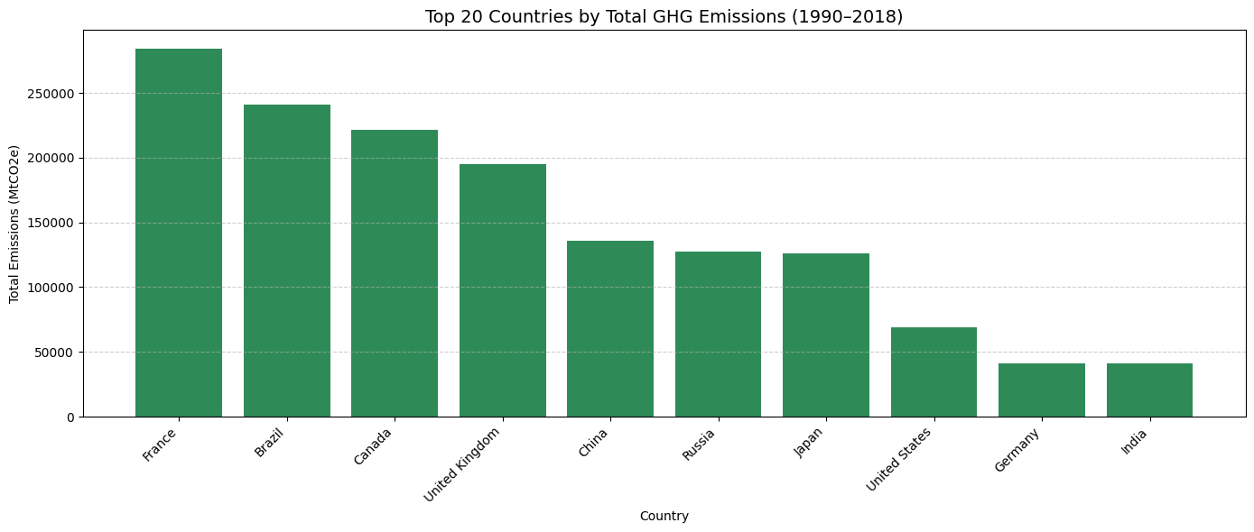
Figure 1. Countries ranked by total GHG emissions, 1990–2018.

2. Time-Series Decomposition
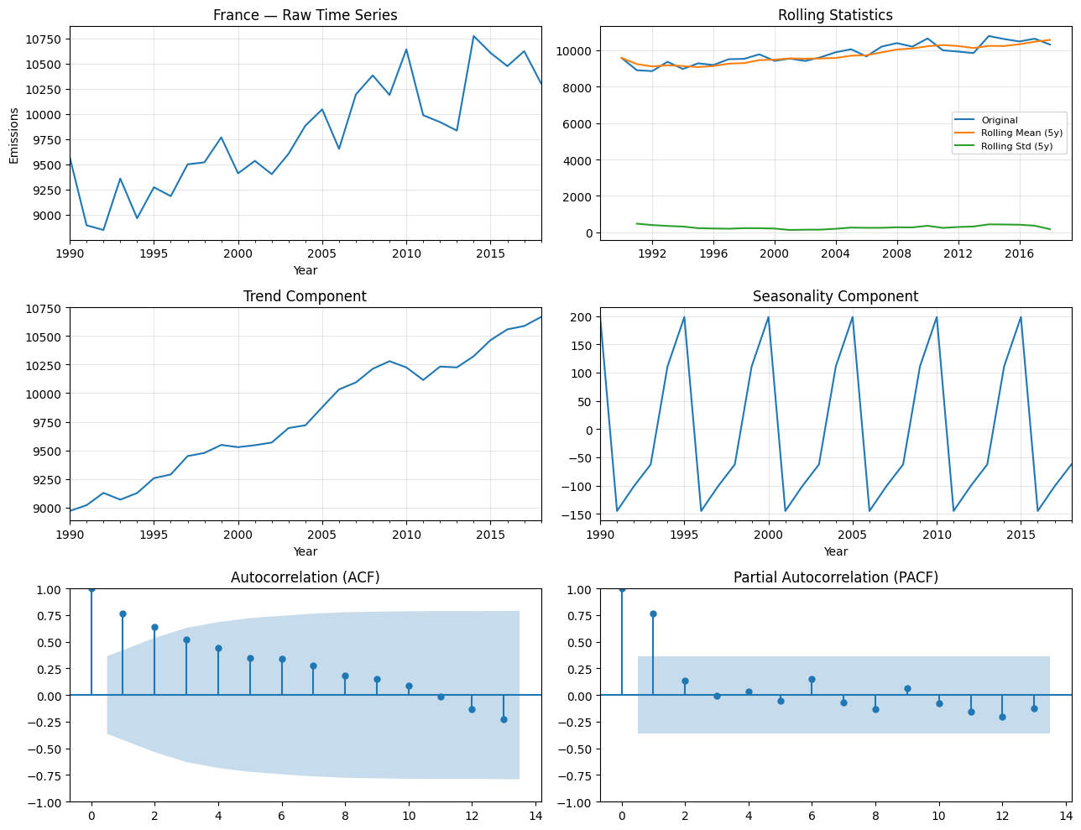
Figure 2. Raw series, rolling statistics, trend/seasonal decomposition, and ACF/PACF for a sample country.

3. Model Fit — Actual vs. Predicted
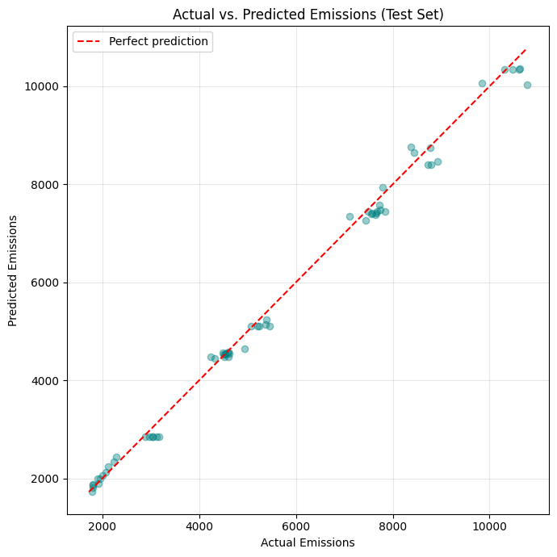
Figure 3. Actual vs. predicted emissions on the held-out test set. Points near the diagonal red line indicate accurate predictions.

4. Feature Importance
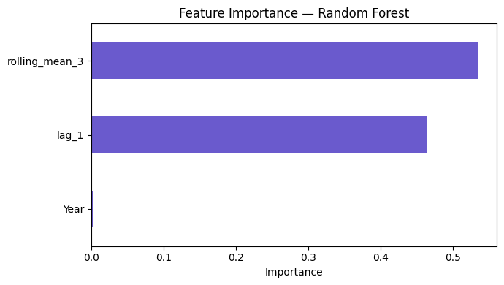
Figure 4. Relative importance of each feature to the Random Forest model.

Discussion
Lag and rolling-average features tend to dominate feature importance, which is expected: national emissions change gradually year to year, so recent history is highly predictive of the near future. The year feature alone contributes comparatively little, since it cannot capture country-specific policy or economic shifts on its own.
Per-country accuracy is expected to vary. Countries with long, stable historical trends should be forecast more reliably than countries with volatile emissions or short/incomplete histories, since the model has fewer patterns to learn from in the latter case.

Conclusion & Future Work
This project demonstrates an end-to-end workflow for analyzing and forecasting national GHG emissions using classical time-series feature engineering combined with a Random Forest Regressor. The interactive components make it easy to explore any country's trend and generate short-term forecasts without modifying code.
Potential extensions:
- Incorporate additional predictors such as GDP, population, and energy mix.
- Compare against dedicated time-series models (ARIMA, Prophet, exponential smoothing).
- Add prediction intervals / uncertainty estimates to forecasts.
- Extend the dataset beyond 2018 as newer emissions data becomes available.

References
- United Nations. International Greenhouse Gas Emissions dataset. Kaggle. https://www.kaggle.com/datasets/unitednations/international-greenhouse-gas-emissions
- scikit-learn documentation: https://scikit-learn.org
- statsmodels documentation: https://www.statsmodels.org

